<https://www.microsoft.com/en-us/sql-server/sql-server-downloads>

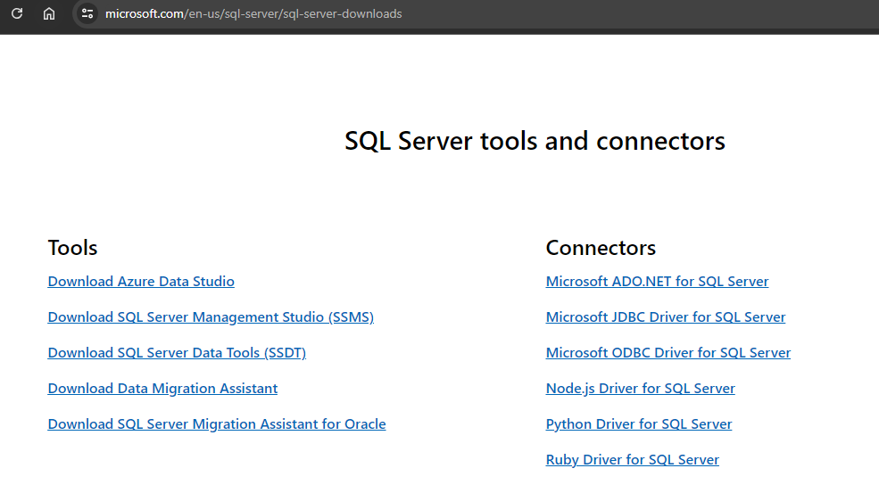

<https://learn.microsoft.com/es-es/sql/ssms/download-sql-server-management-studio-ssms?view=sql-server-ver16>

